Volunteer Best Practices
About
Students that complete the required hours and take the pledge are given a prize and t-shirt by the principal as they are recognized in class.
Steps to Success
- Approach the Principal and ask if the school will support your efforts with Junior Hero. Give the principal a shirt. Give shirts to the front office staff. Explain that the program is free to the school and that it is not a burden on the staff. Participating schools have all reported increased enthusiasm for good citizenry.
- Distribute service logs to each student by way of teacher’s boxes.
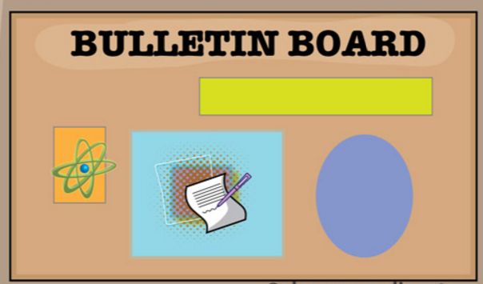
- Put up a Junior Hero board at your elementary school. Decorate it with the t-shirt and prize. Include “take” and “turn in” folders on the board where students can pick up a Junior Hero service log sheet and turn it in when they are finished. You will want to make sure the “take” folder is always full of service logs.
- Give shirts to the principal and visible staff in the front office. They will wear the shirts and help you to spread awareness.
- Let the teachers know that they can work with their class on service projects together to become Junior Heroes.
- Check the board on a weekly basis and collect any completed service logs. Ensure that the required number of hours has been fulfilled and the service has been rendered. Discourage “service” that students would do regardless, such as their chores around the house.
Required Service Hours
Pre-K: 4 Hours
Kindergarten: 4 Hours
1st Grade: 6 Hours
2nd Grade: 8 Hours
3rd Grade: 10 Hours
4th Grade: 12 Hours
5th Grade: 14 Hours
6th Grade: 16 Hours
Adults: 10 Hours
- Match each completed form with a t-shirt and prize and leave with the school staff at the front desk. The Principal will visit each classroom to award the new Junior Hero and highlight specific service from the service log in front of the class.
- Ideas to raise awareness include: recognizing new Junior Heroes over the intercom, putting the Junior Hero names on the board, get into morning announcements, give a two-minute pitch at a PTA meeting, set up a booth at a school event, get information into the weekly email to parents, etc.
- To start, you’ll be given a supply of shirts and prizes. When you run out, email theagreaves@gmail.com for more supplies.
Junior Hero Pledge

As a Junior Hero, I pledge to uplift others and myself through thoughtful acts of
kindness and service.
- Make sure the program is well known around the school. Involvement in the program builds on itself. Once a few students become Junior Heroes, many will want to participate.
- Don’t hesitate to contact theagreaves@gmail for any help of questions.

